Configure Chronicle App Integration Setup In Salesforce
This tutorial guides you through setting up the Chronicle App integration within Salesforce.
Latest version 1.4
Installation:
Prod:
https://login.salesforce.com/packaging/installPackage.apexp?p0=04tgK0000007Bl7QAE

Sandbox:
https://test.salesforce.com/packaging/installPackage.apexp?p0=04tgK0000007Bl7QAE

Password: Chr0nicle
1. Introduction
You will configure installation, matching rules, API connections, and permission sets to enable seamless operation.

2. Click Password Field
Click the Password field to begin the installation process.
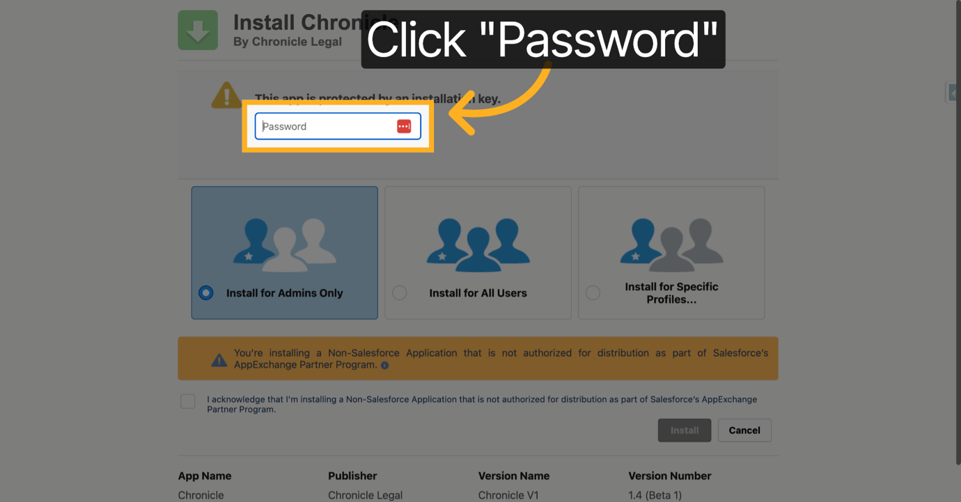
3. Enter Your Password
Enter your password to authenticate the installation.
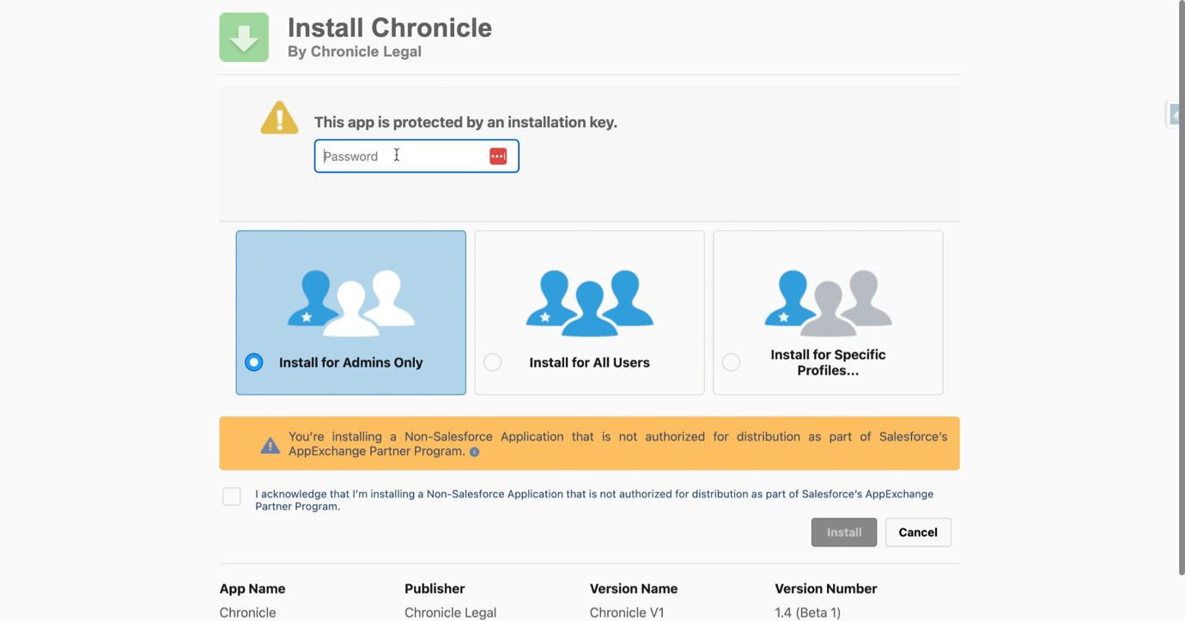
4. Select Install for Admins Only
Select the option to install the app for admins only to restrict access.
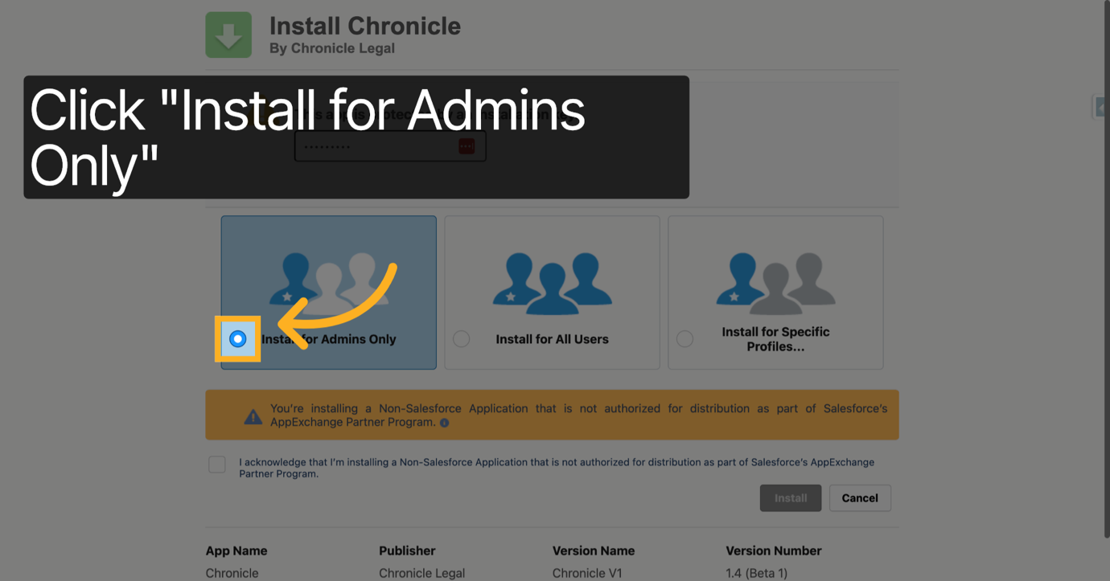
5. Confirm Install for Admins Only
Confirm the selection to install the app for admins only.
6. Acknowledge Non-Salesforce App Installation
Acknowledge that you are installing a Non-Salesforce Application not authorized for distribution through AppExchange.
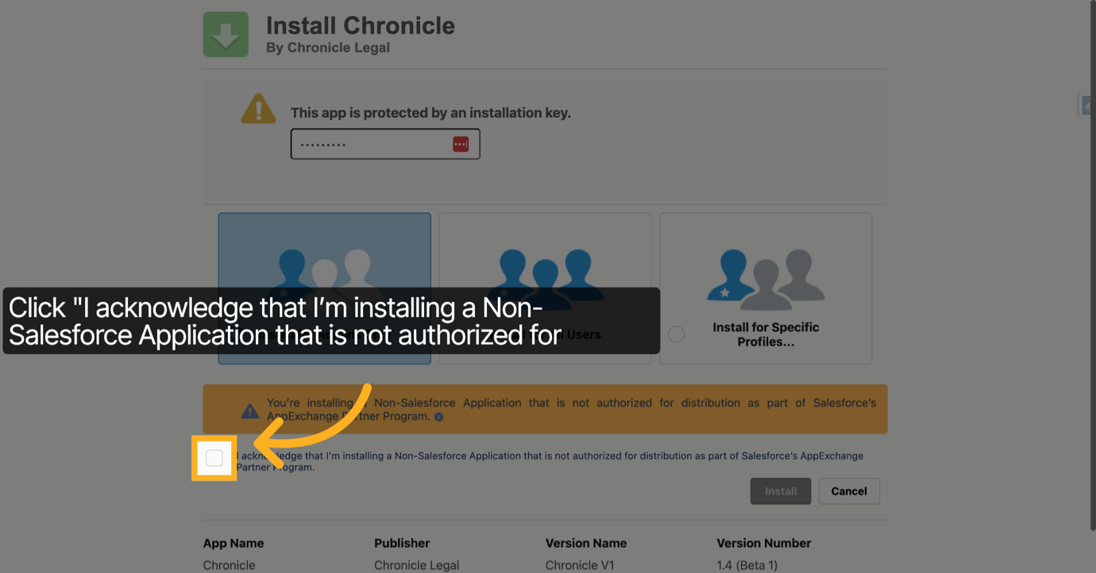
7. Click Install Button
Click the Install button to start installing the Chronicle App.
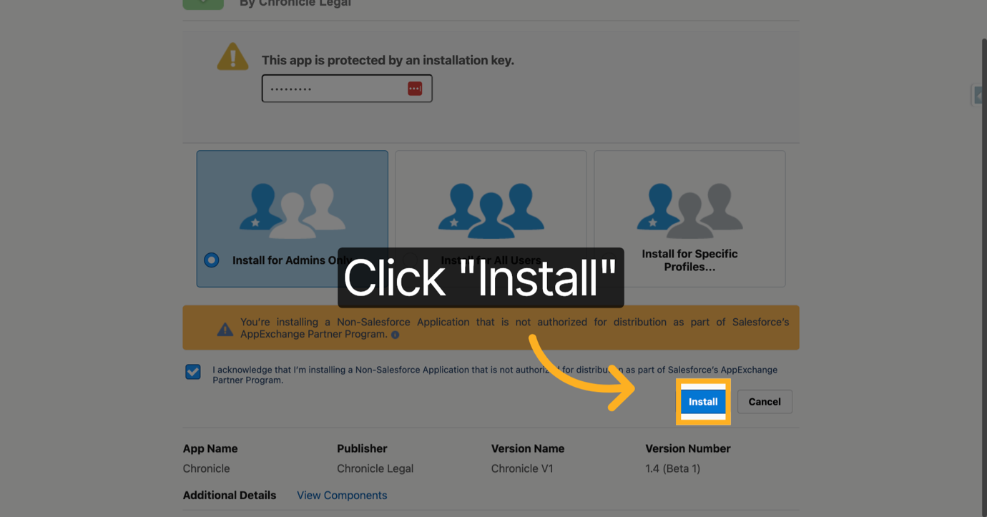
8. Click Done After Installation
Click Done once the installation completes to continue.
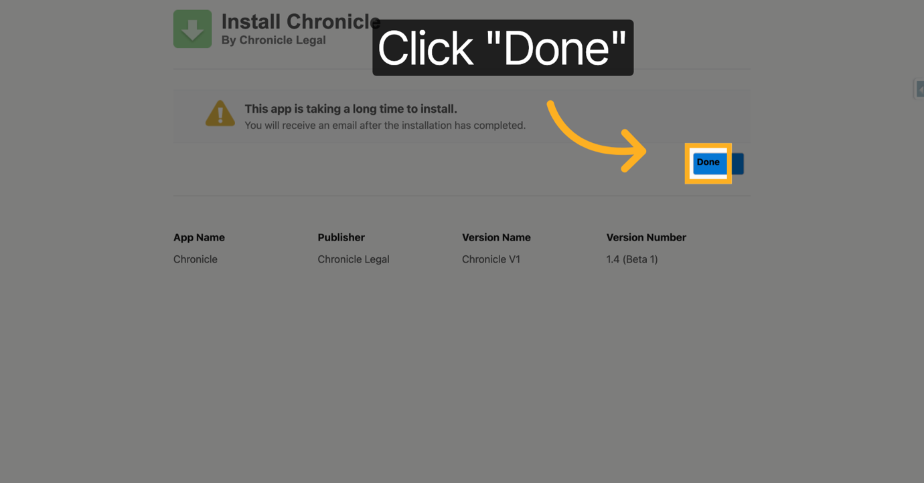
9. Confirm Installation was successful
Confirm that the Installation was successful in the Installed Packages section
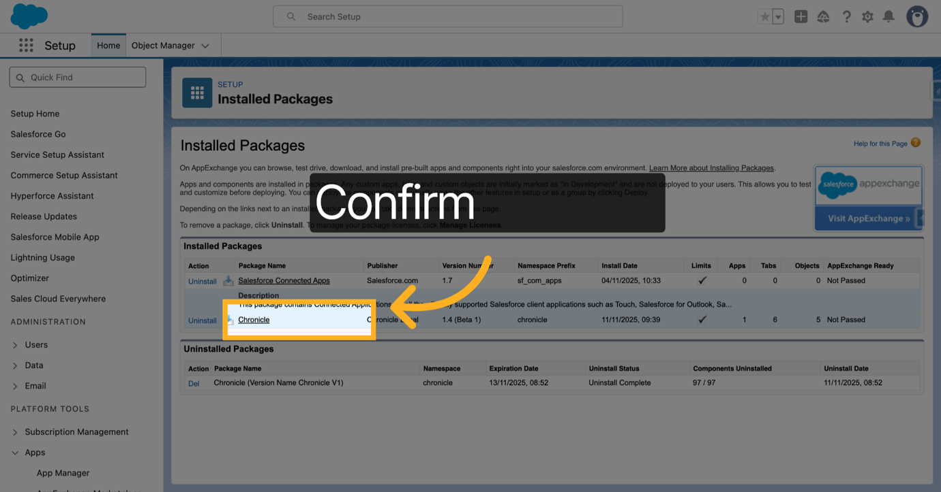
10. Open App Launcher
Click the App Launcher to find and open the Chronicle app.
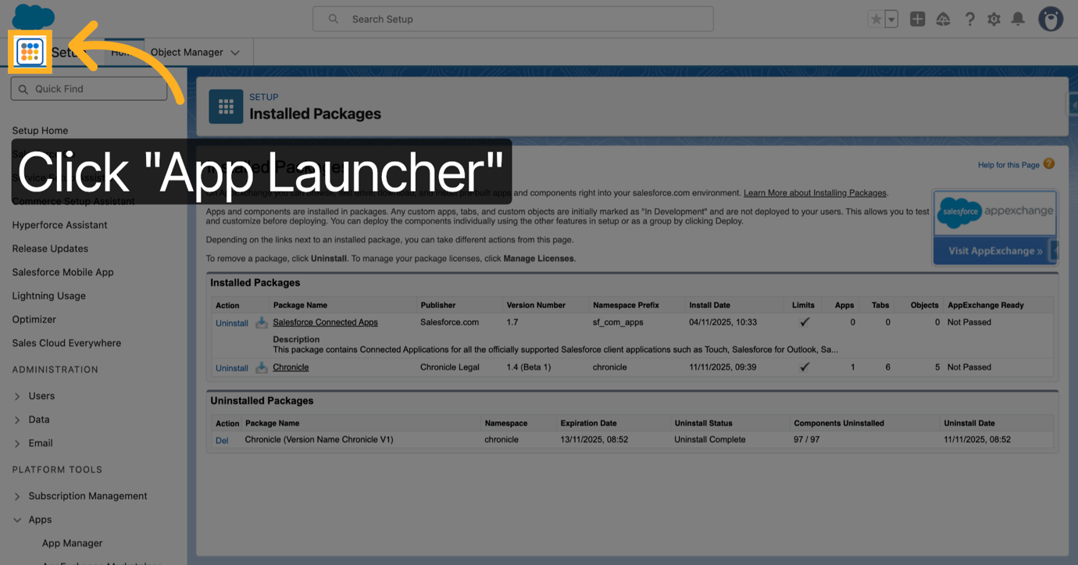
11. Search for Chronicle App
Type 'Chronicle' in the search bar to locate the Chronicle app quickly.
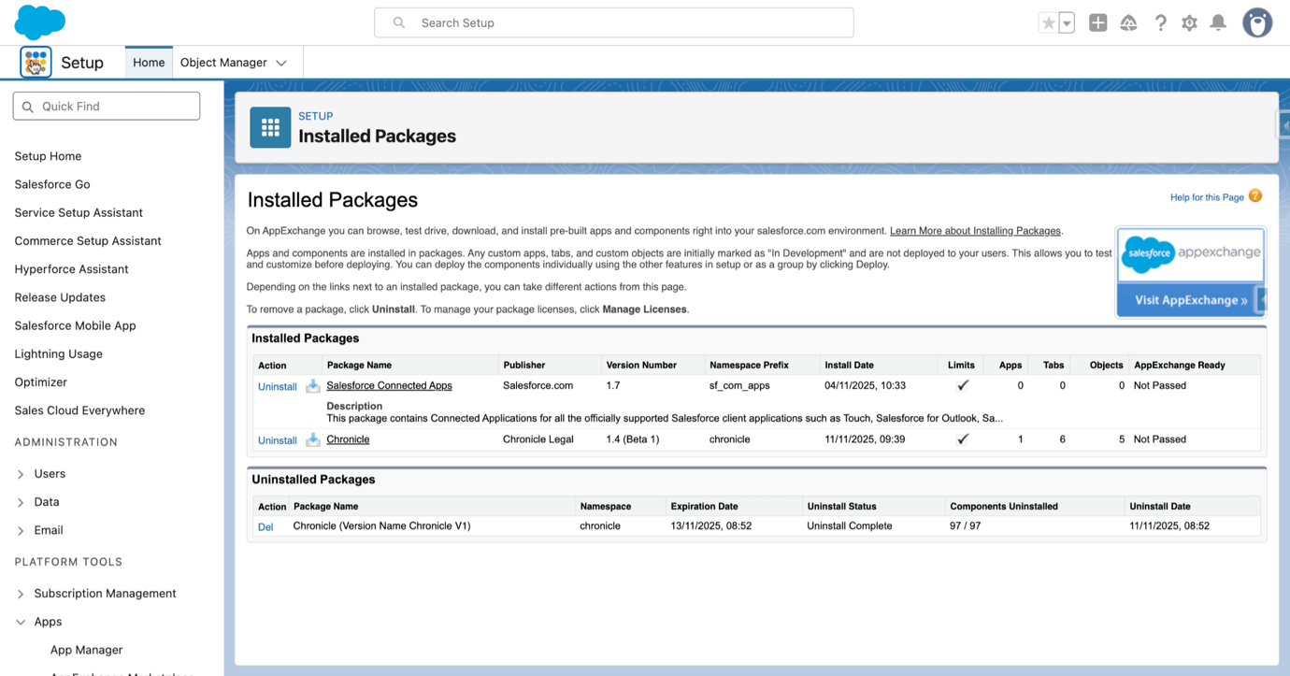
12. Select Chronicle App
Click Chronicle to open the application interface.
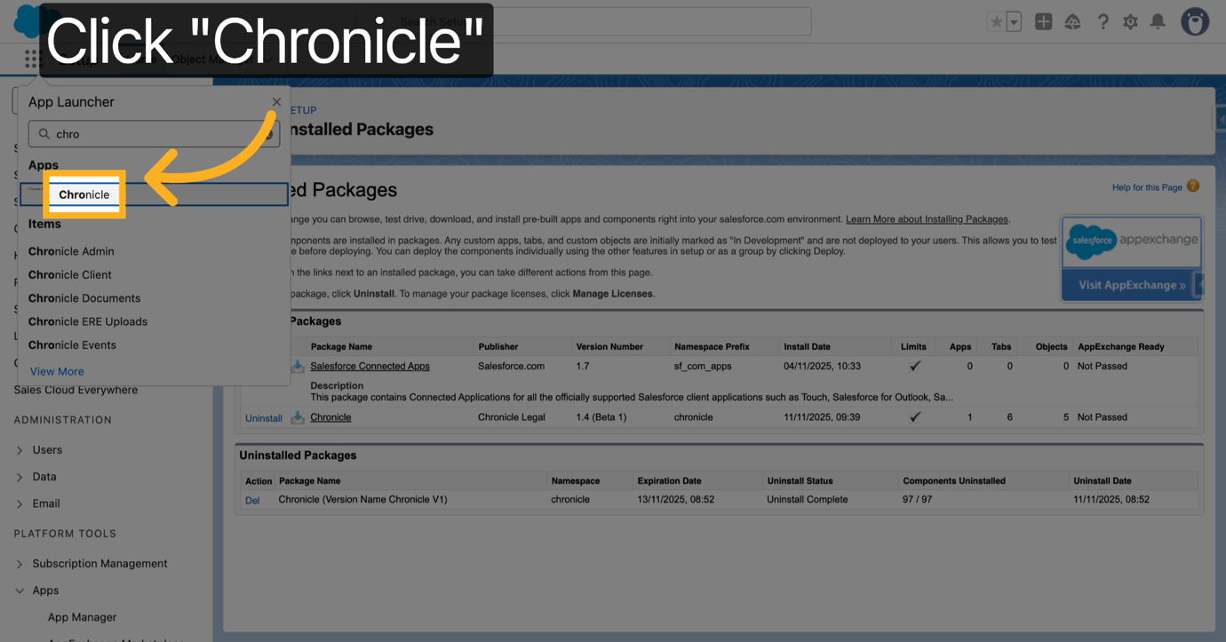
13. Switch to Lightning Experience
Switch to the Salesforce Lightning Experience environment for configuration.
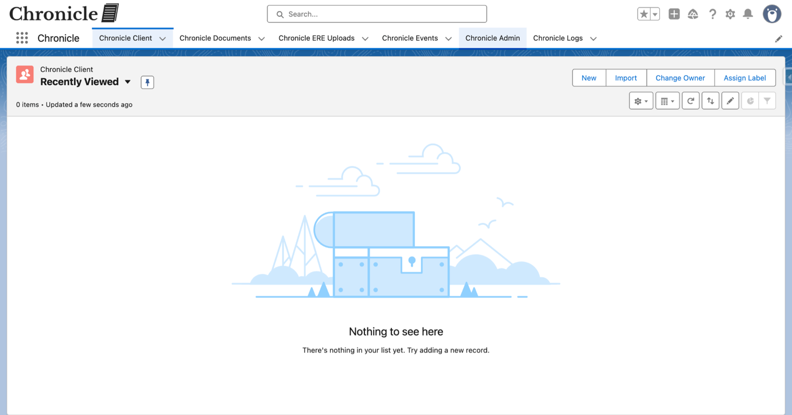
14. Open Chronicle Admin
Click Chronicle Admin to access administrative settings.
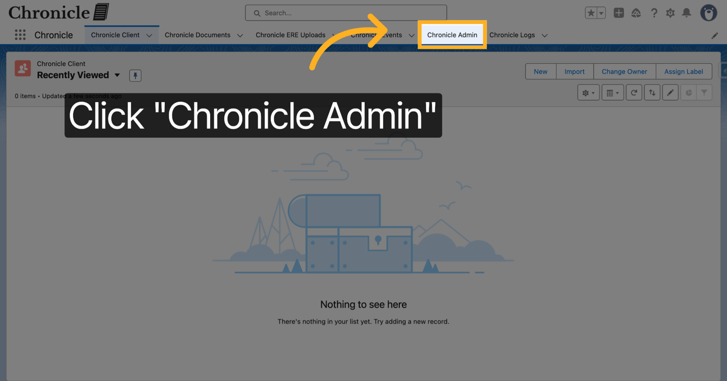
15. Create New Matching Rule
Click New Matching Rule to define criteria for matching records.
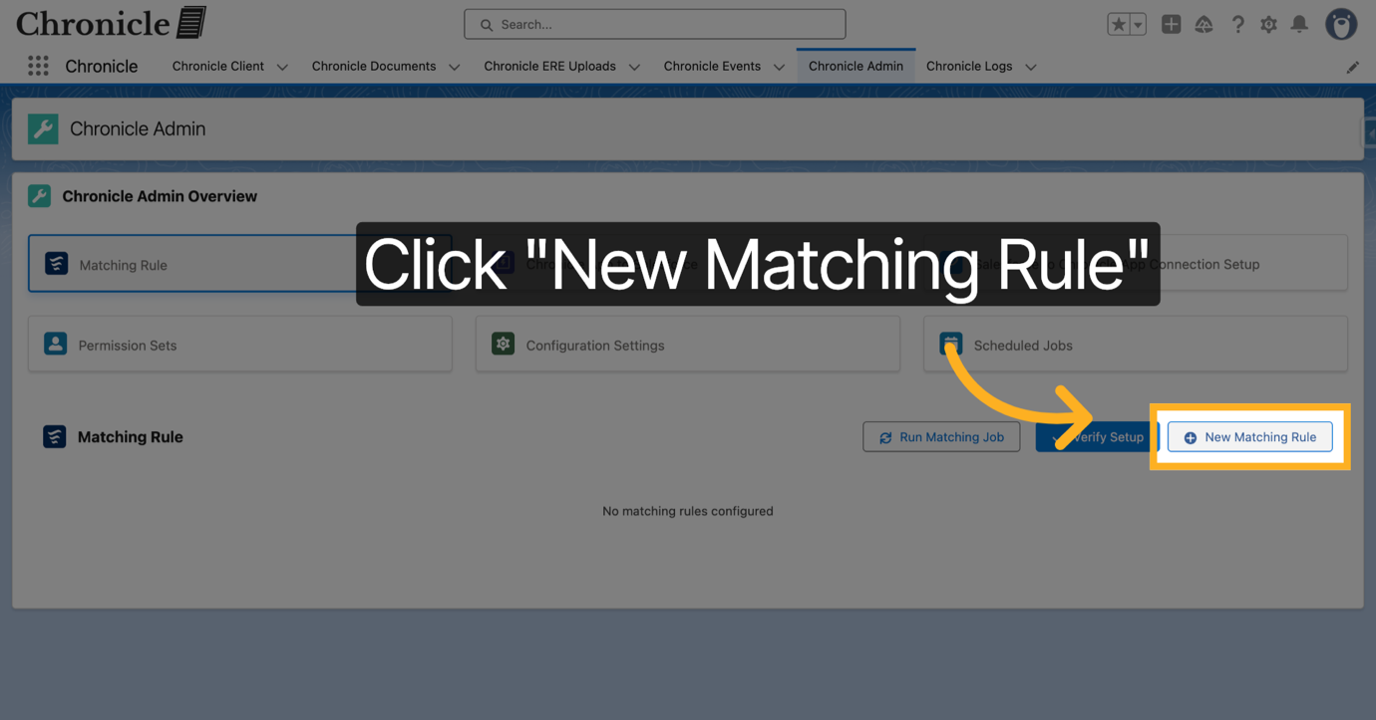
16. Confirm Account Object Selection
Confirm the selection of the Account object for the matching rule. This is the object where you want to link the incoming Chronicle Client records
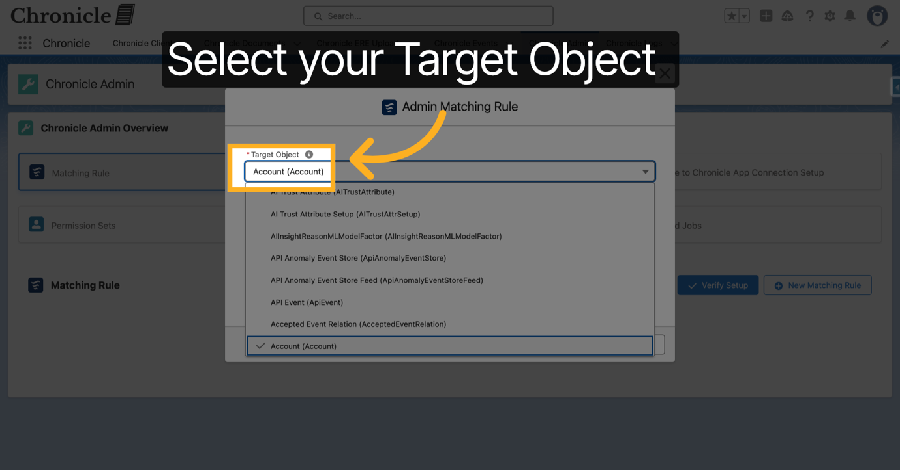
17. Select the lookup field on the Chronicle Client
Select the "Matched Account" for Accounts. You will need to create a lookup field on the Chronicle Client object to your selected Target Object if it is not the Account object.
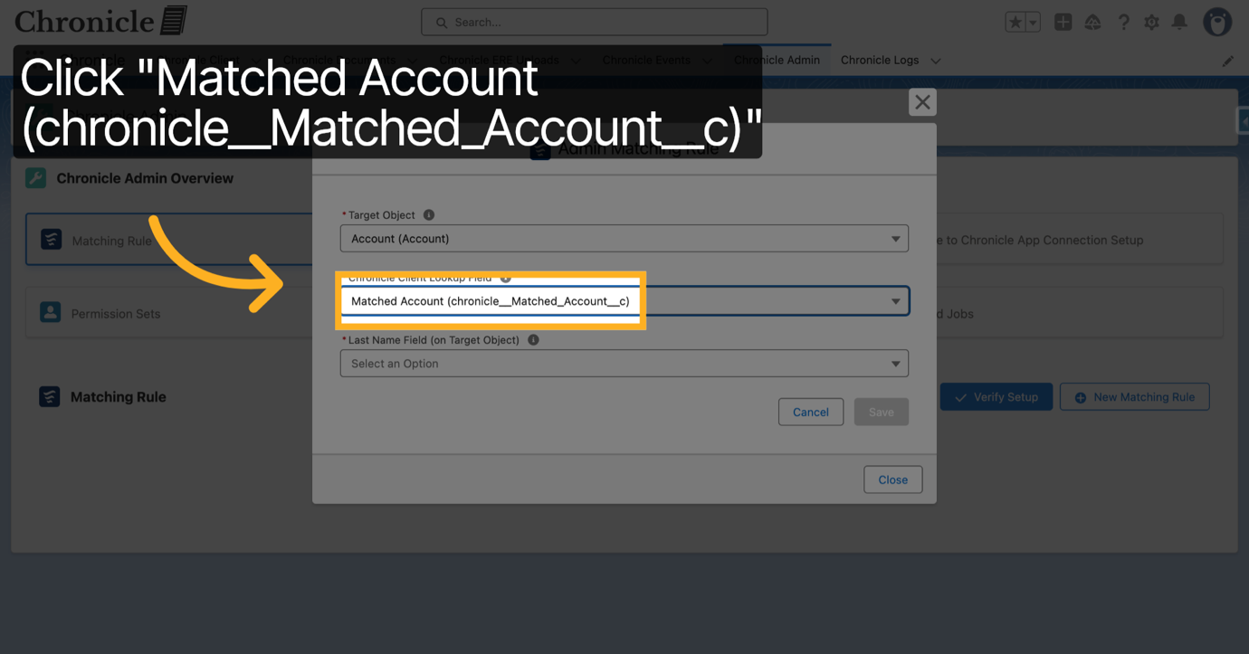
18. Open "Last Name" Field Selection Dropdown
Select the field on the target object that holds the person's last name.
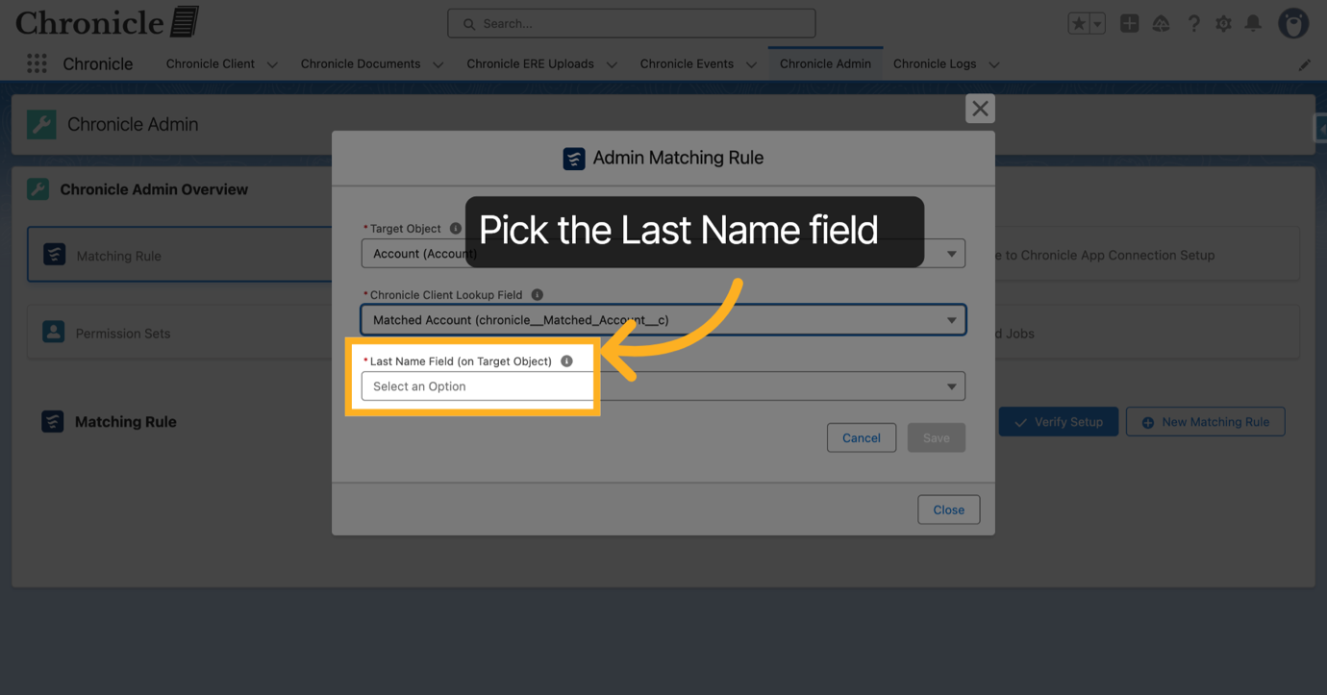
19. Next select the Full SSN Field
Select the field on the Target Object that holds the full SSN.
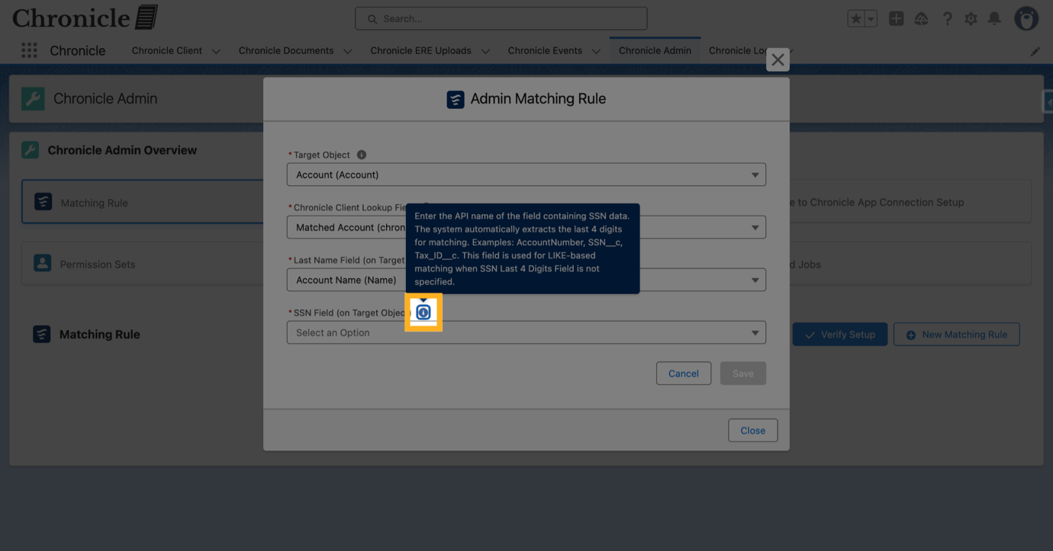
20. Select the Last 4 SSN
If the full SSN field is encrypted, then this setting is required since encrypted fields aren't filterable in SOQL. This field should hold the unencrypted plain text version of the last 4 digits of the SSN. If you do not have this available, then ask your Salesforce admin or developer to create one. If you need any assistance with this step, please reach out to the Chronicle Legal team, and we can assist. This setting is optional if the full SSN field is an unencrypted text field.
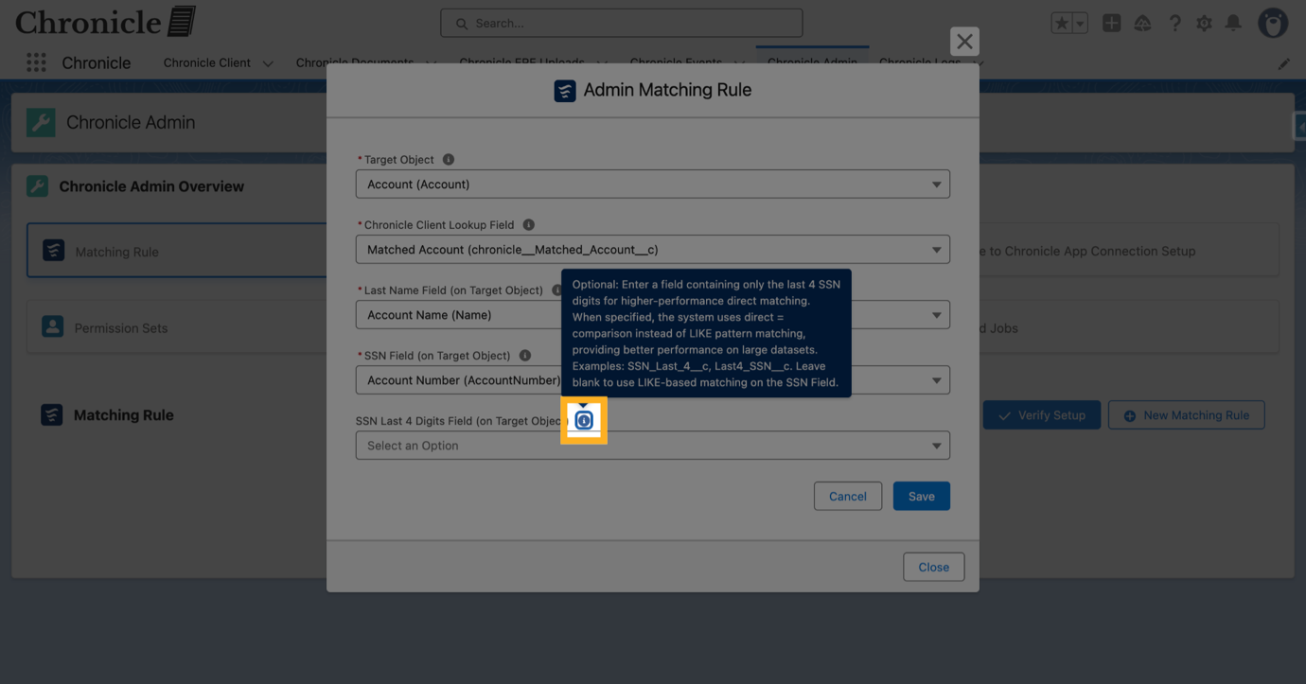
21. Cancel or Save Matching Rule
Choose to cancel or save the matching rule configuration. This creates a new Custom Metadata record asynchronously, which usually takes a couple of seconds but can take a little longer.
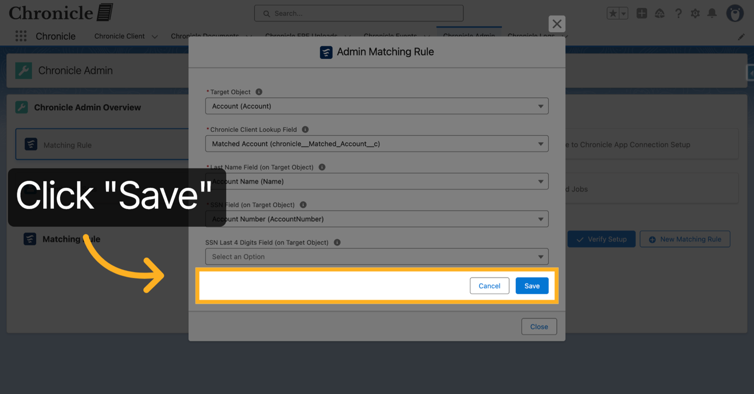
22. Verify Setup Completion
Once you see the created matching setting, click Verify Setup to confirm the matching rule is correctly configured.
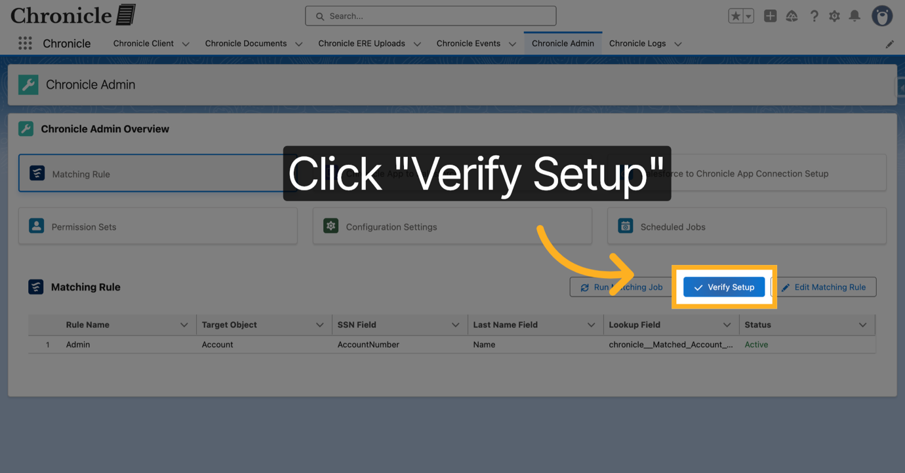
23. Close Verification Window
Click Close to exit the verification window.
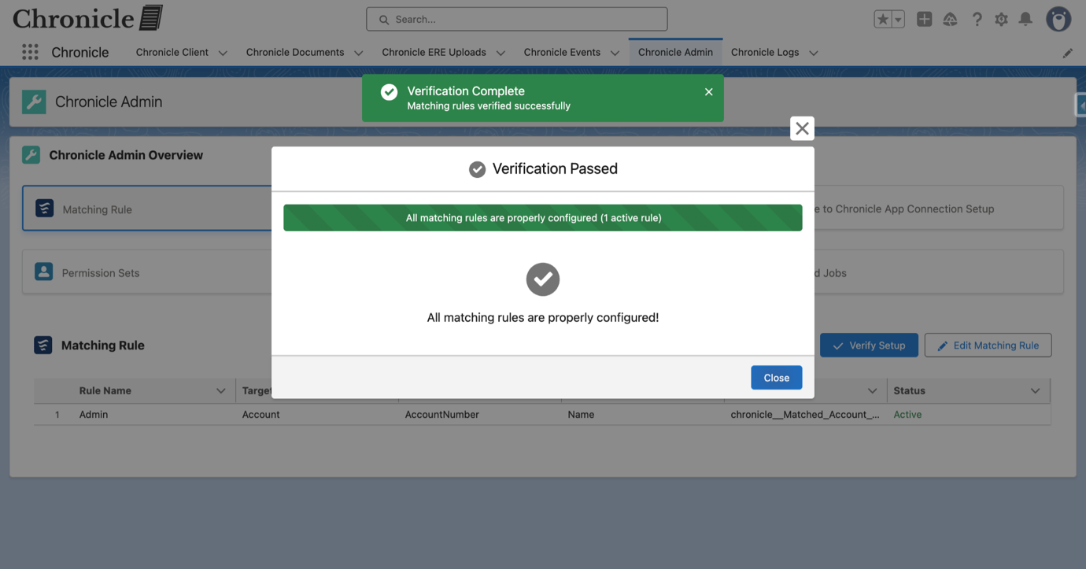
24. Open Chronicle App to Salesforce
Click "Chronicle App to Salesforce" to view instructions on setting up the External Client App so that the Chronicle App can push records into Salesforce.
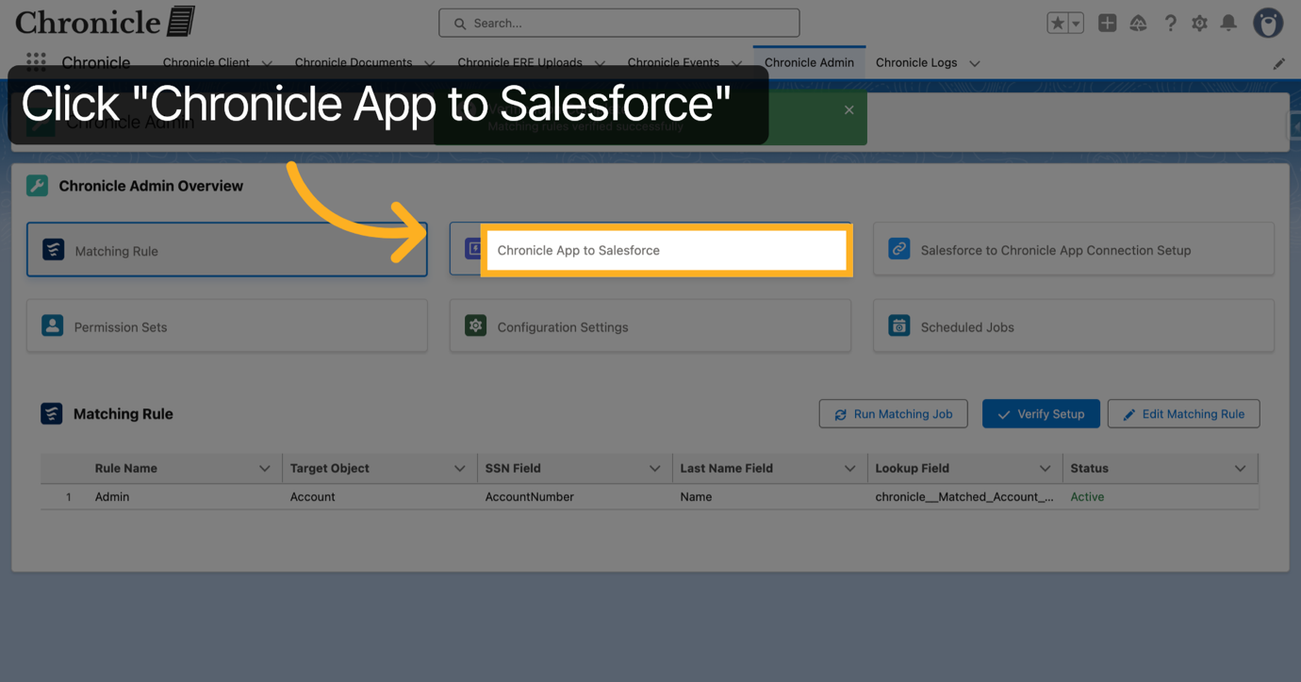
25. Note the following
Note the "OAuth Start URL" and the fact that the integration user you select needs to have the "Chronicle Integration User" permission set
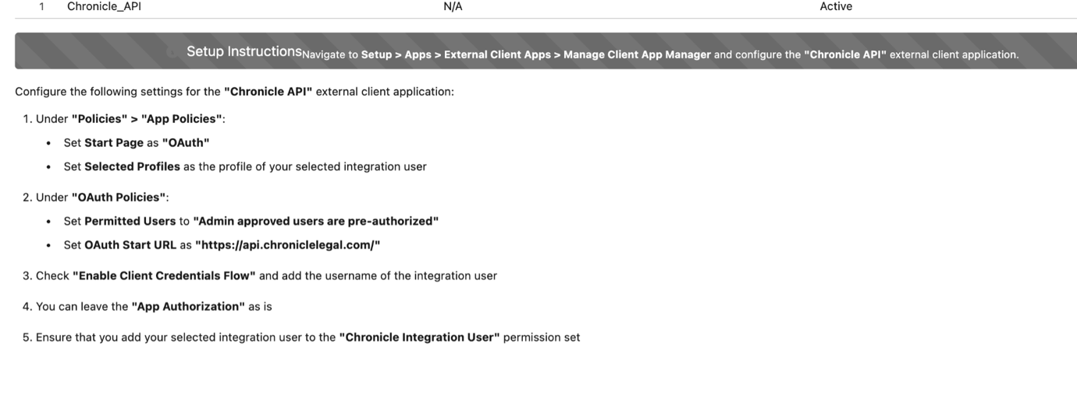
26. Open Salesforce Setup
Click Setup to access Salesforce configuration options.
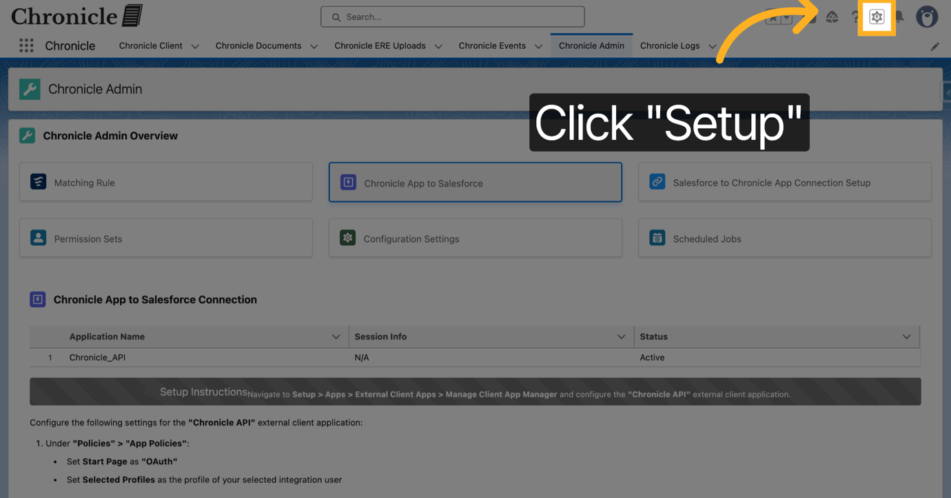
27. Open External Client App Manager
Click External Client App Manager to manage connected client applications.
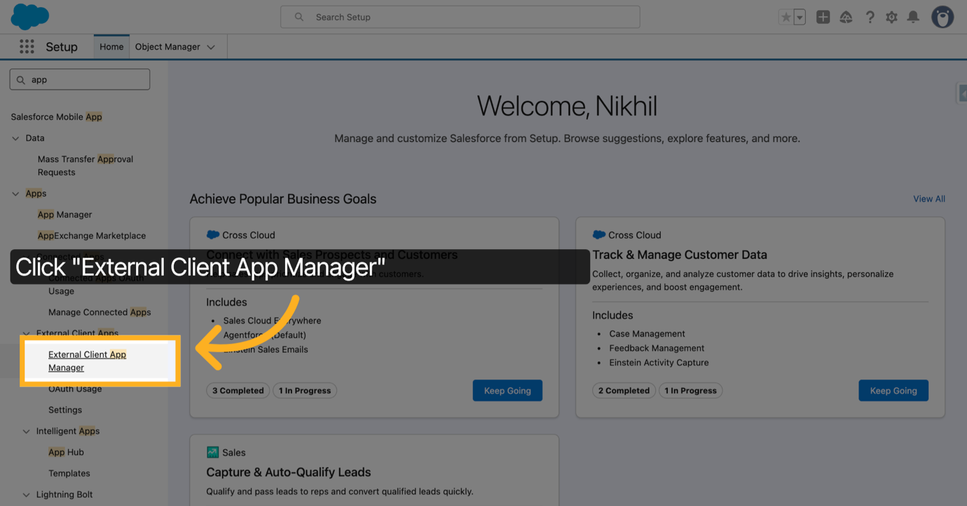
28. Select Chronicle API App
Click Chronicle API to configure API settings for the app.
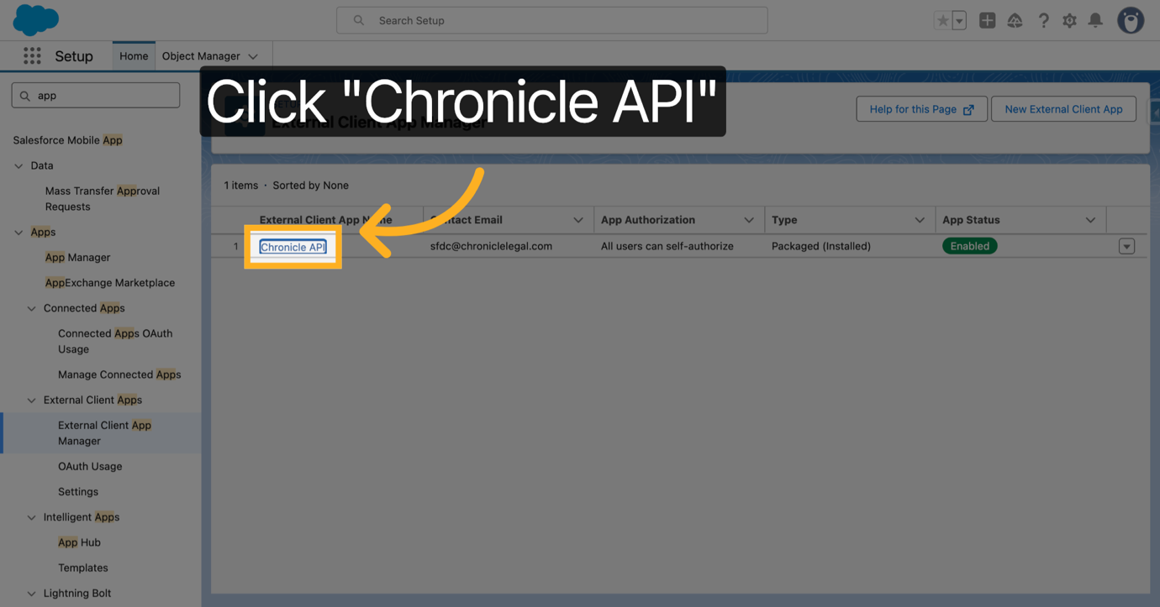
29. Click Edit Button
Click Edit to modify the API app settings.
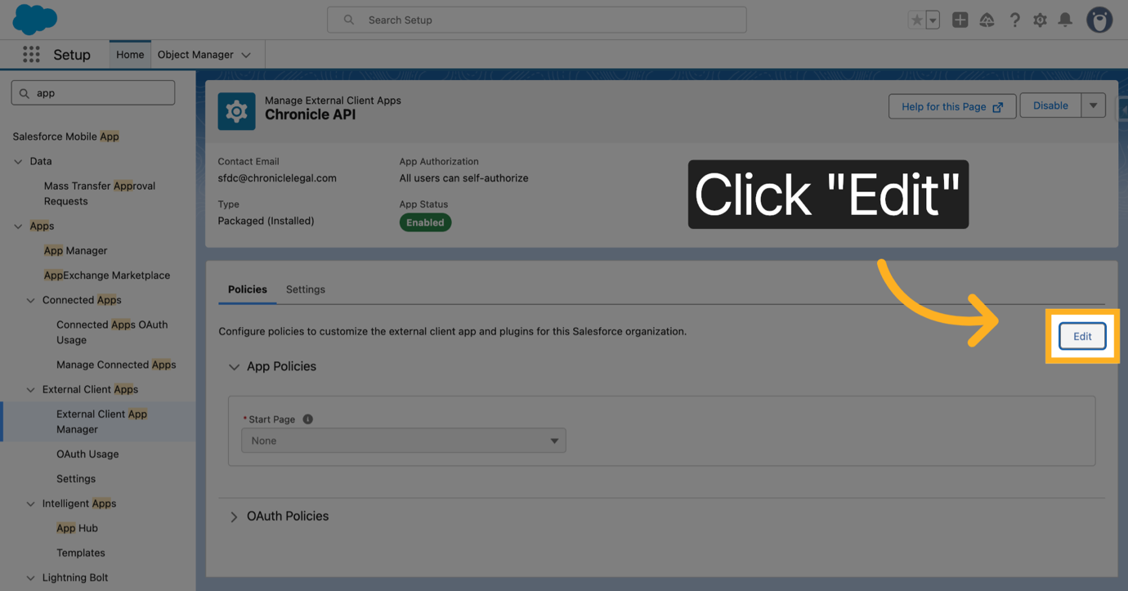
30. Open OAuth Settings
Click OAuth to access authentication policies.
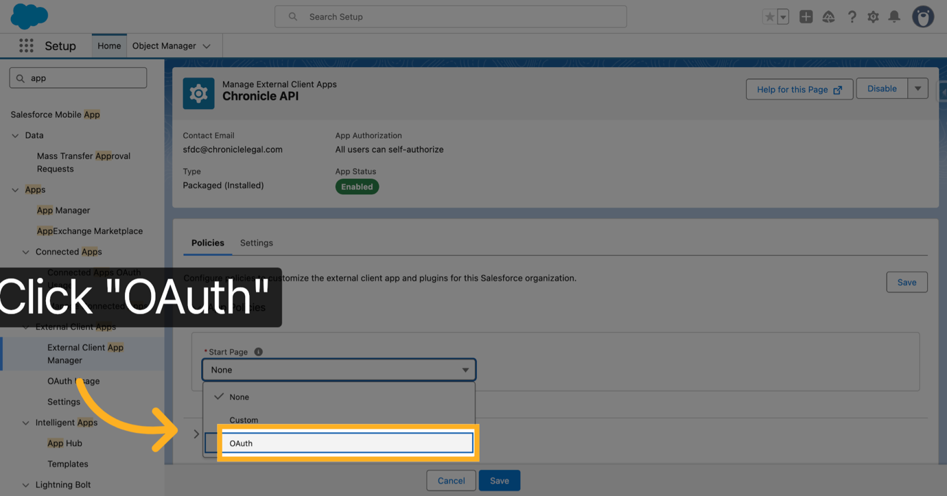
31. Open OAuth Policies
Click OAuth Policies to configure user authorization settings.
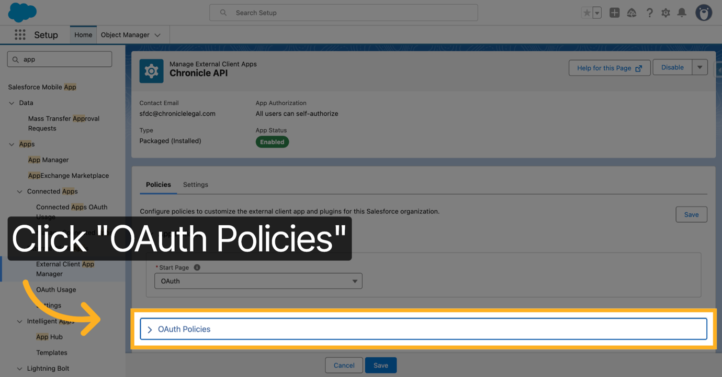
32. Select All Users Can Self-Authorize
Under "Open OAuth Policies" then "Permitted Users. Click All users can self-authorize to allow users to grant access themselves.
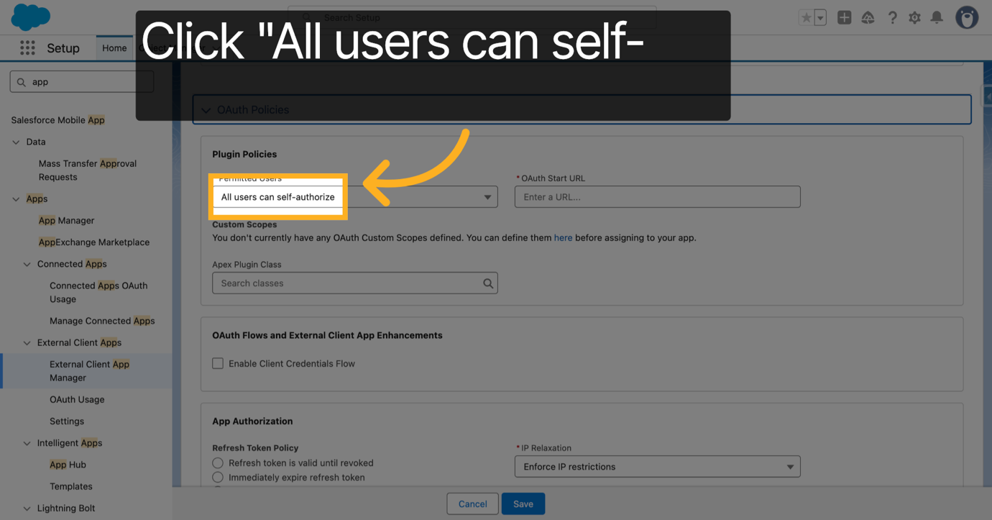
33. Select Admin Approved Users
Click Admin approved users are pre-authorized to restrict access to approved users.
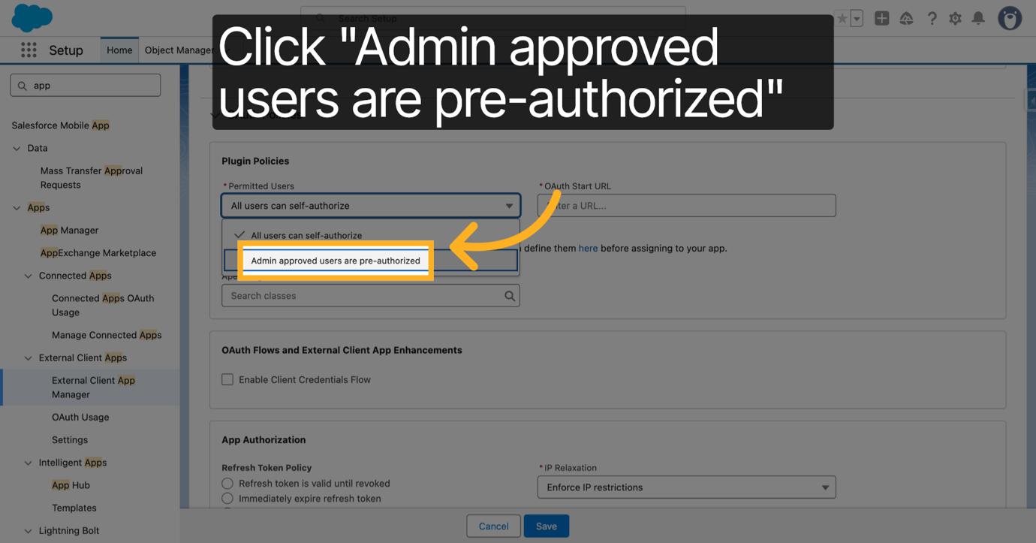
34. Confirm OAuth Policy Changes
Click OK to save the OAuth policy changes.
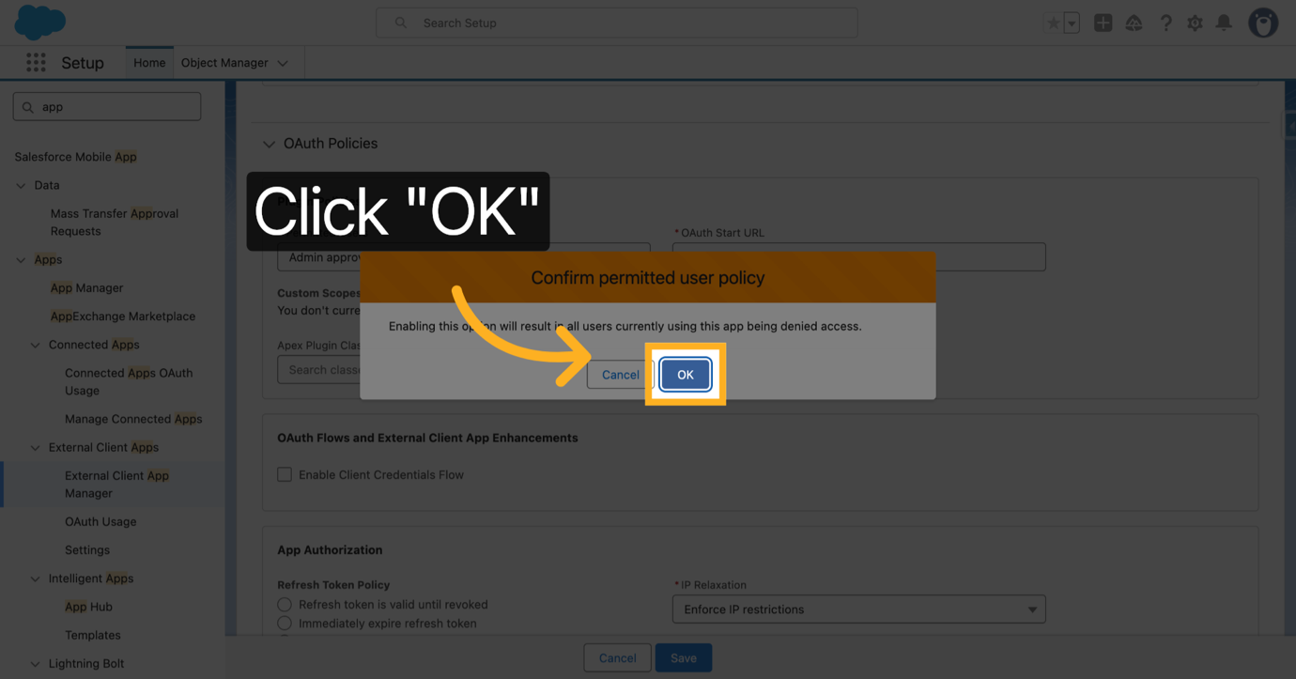
35. Select The profile of your Integration user
Select the profile of your integration user. We recommend you use a dedicated integration user for this integration.
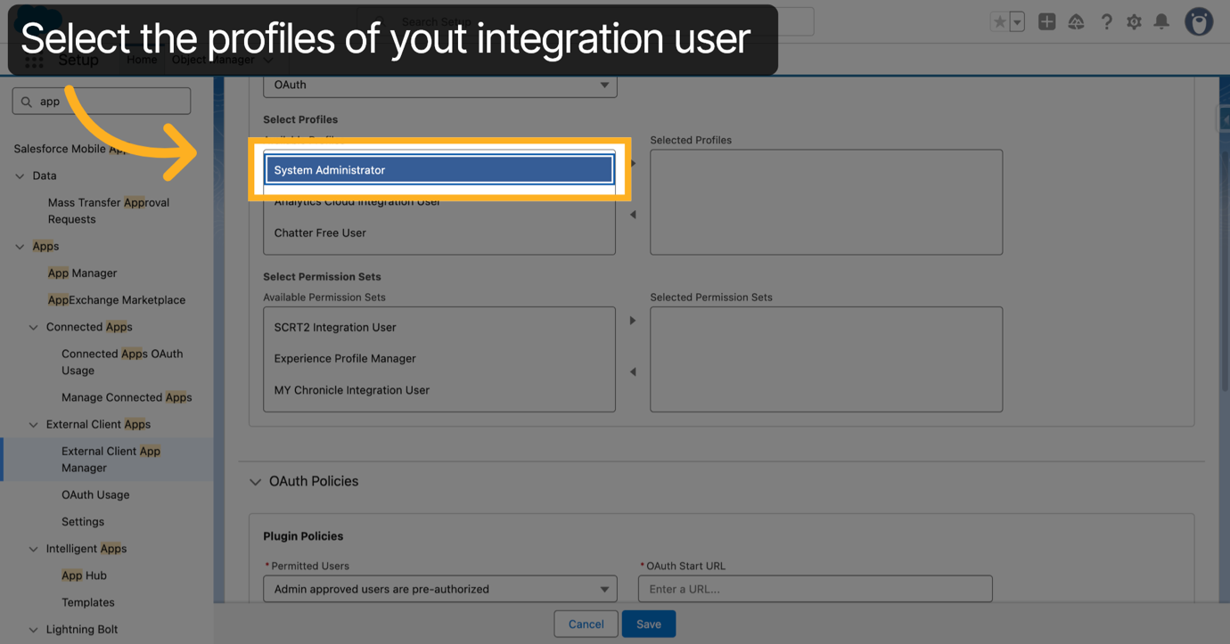
36. Switch to Lightning Experience
Switch to the Lightning Experience interface for profile configuration.
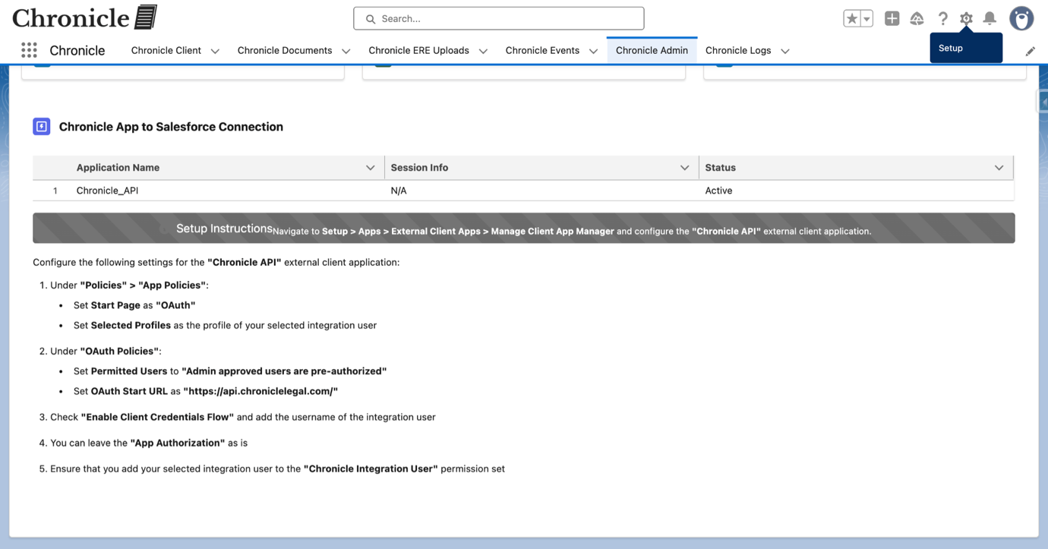
37. Open API URL
Click the API URL to verify the endpoint for integration.
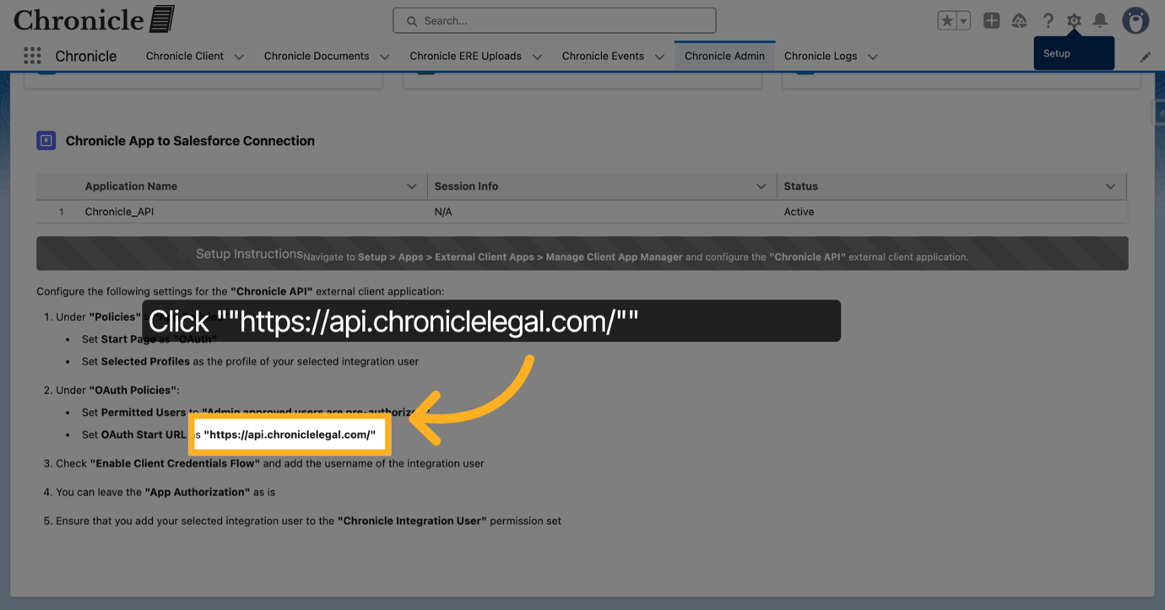
38. Switch to Salesforce Setup Org
Switch back to the setup organization for further configuration.
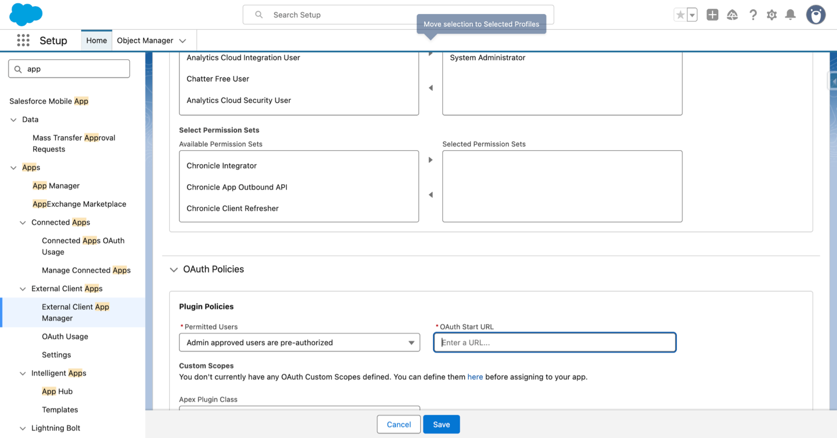
39. Select OAuth Start URL Field
Click the OAuth Start URL field to specify the OAuth login endpoint.
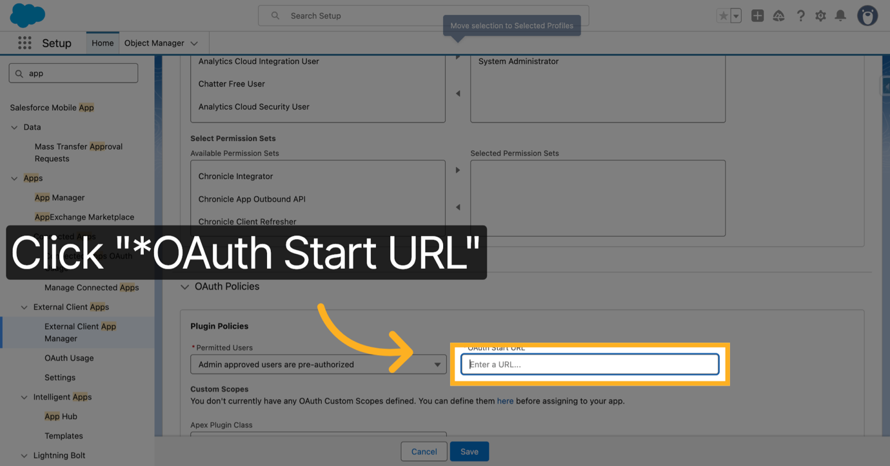
40. Enable Client Credentials Flow
Enable the Client Credentials Flow to allow server-to-server authentication.
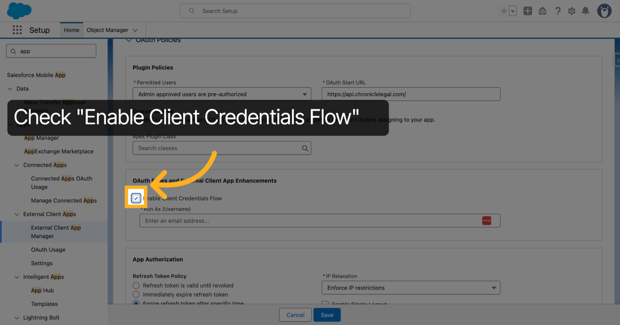
41. Enter Integration Username
Enter the username for the integration user to run API flows.
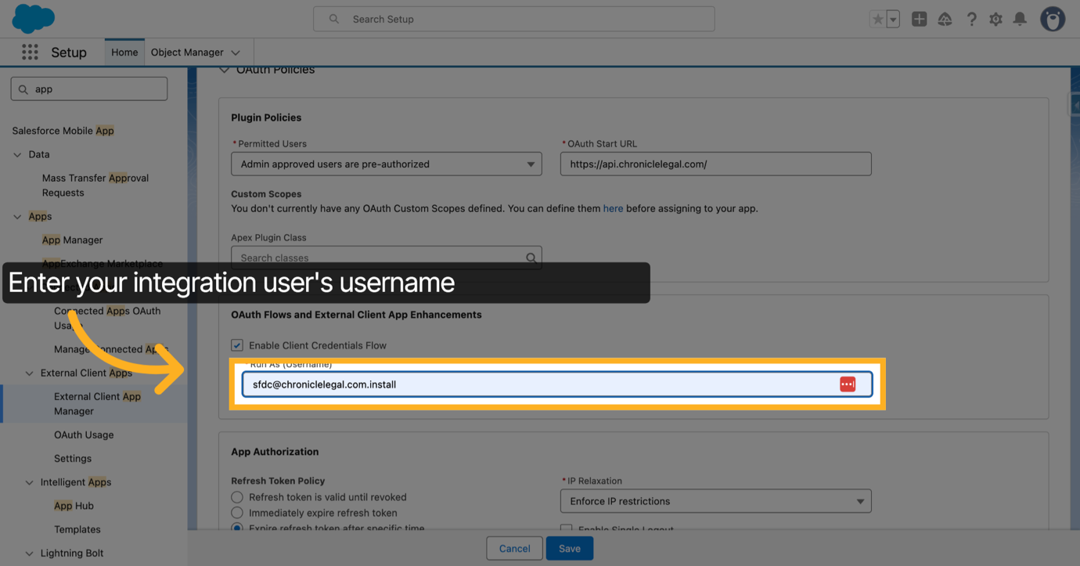
42. Save OAuth Configuration
Click Save to apply the OAuth configuration changes.
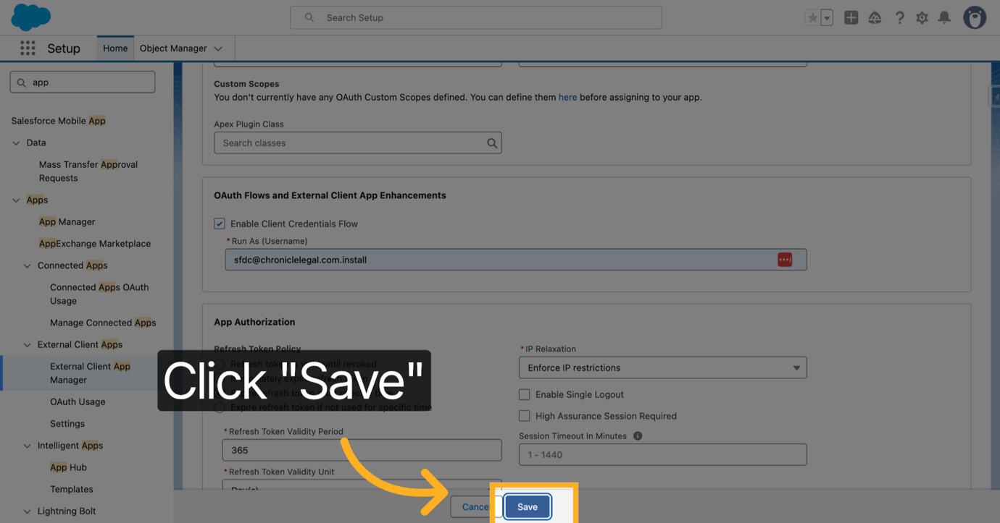
43. Open Salesforce to Chronicle Setup
Click Salesforce to Chronicle App Connection Setup to configure API integration from Salesforce to Chronicle
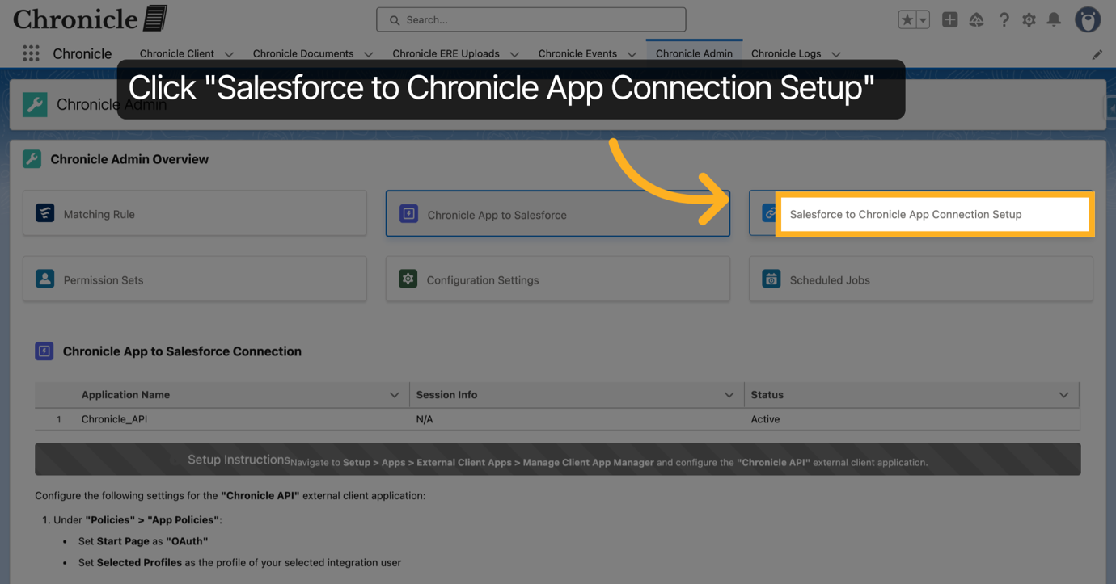
44. Enter Chronicle API Key
Enter your Chronicle API key to authenticate API requests. If you don't have this, contact the Chronicle Legal team.
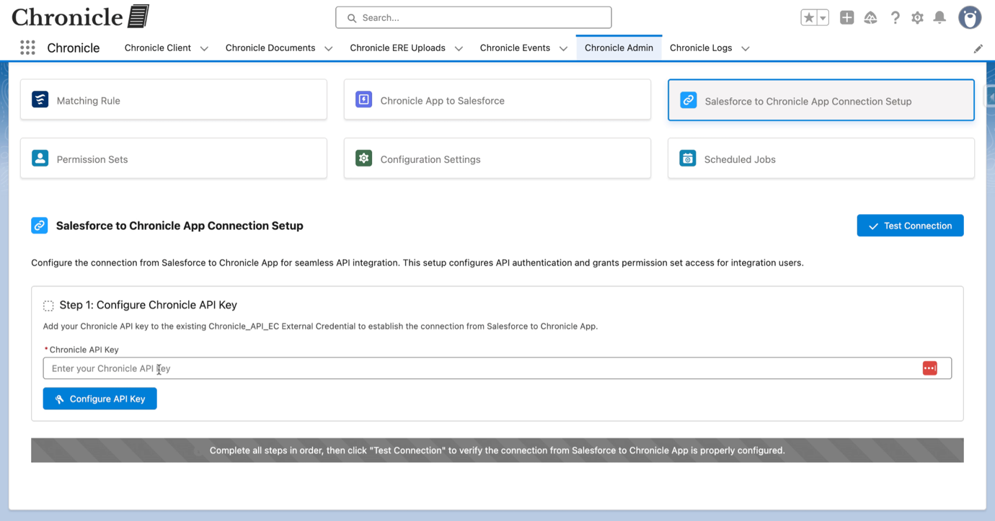
45. Configure API Key
Click Configure API Key to save and apply the key.
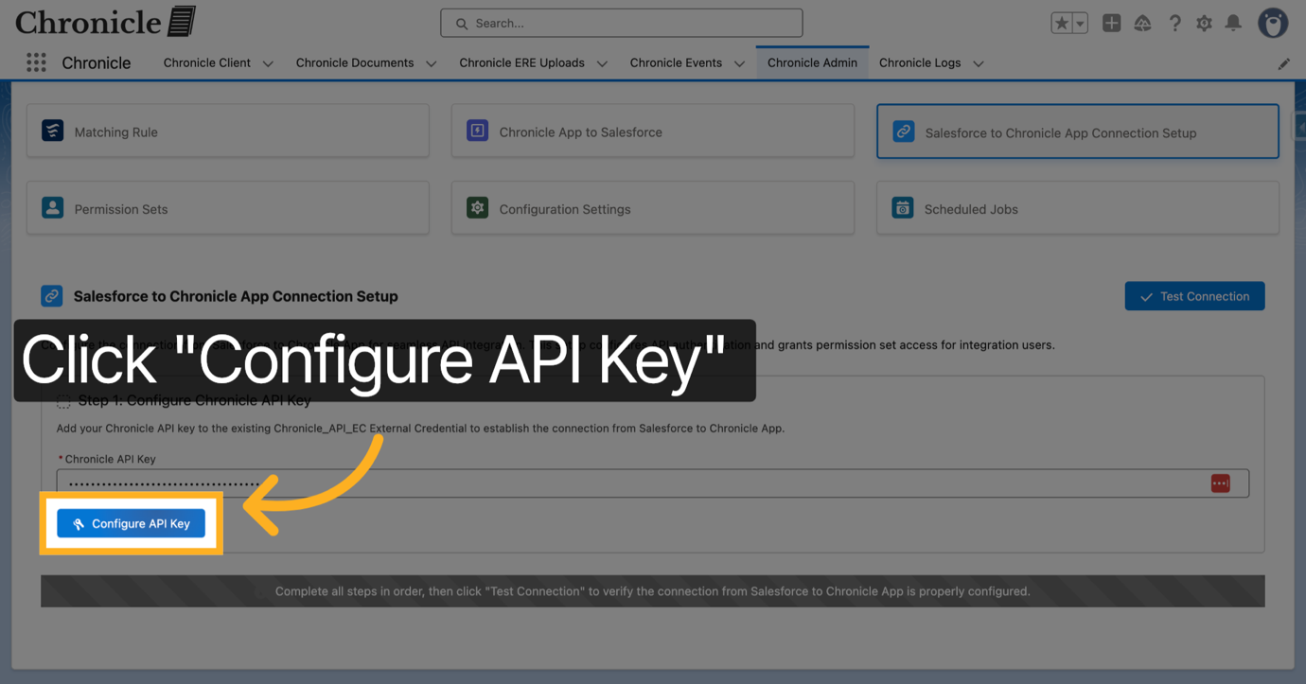
46. Open Permission Set Creation Step
Click Step 2: Create Permission Set to proceed with permission set configuration. This permission set will be used to assign users the permission to use the Salesforce to Chronicle App API calls: Upload ERE Documents, Update full SSN and Refresh the Client in the Chronicle App.
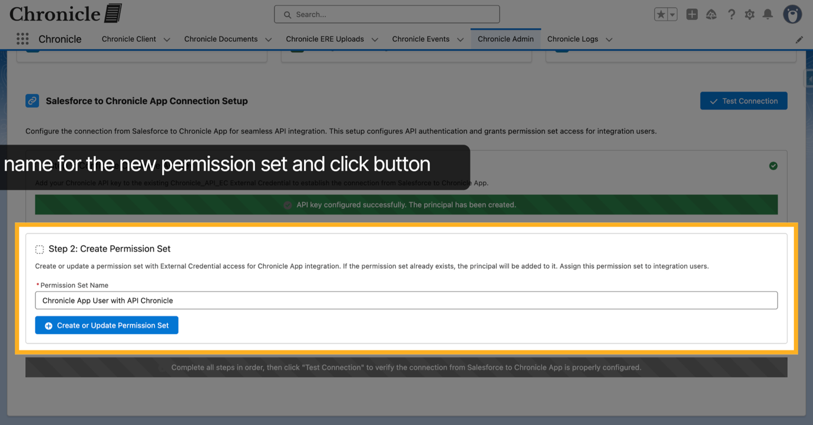
47. Test API Connection
Once the process completes, click Test Connection to verify that the API integration is working.
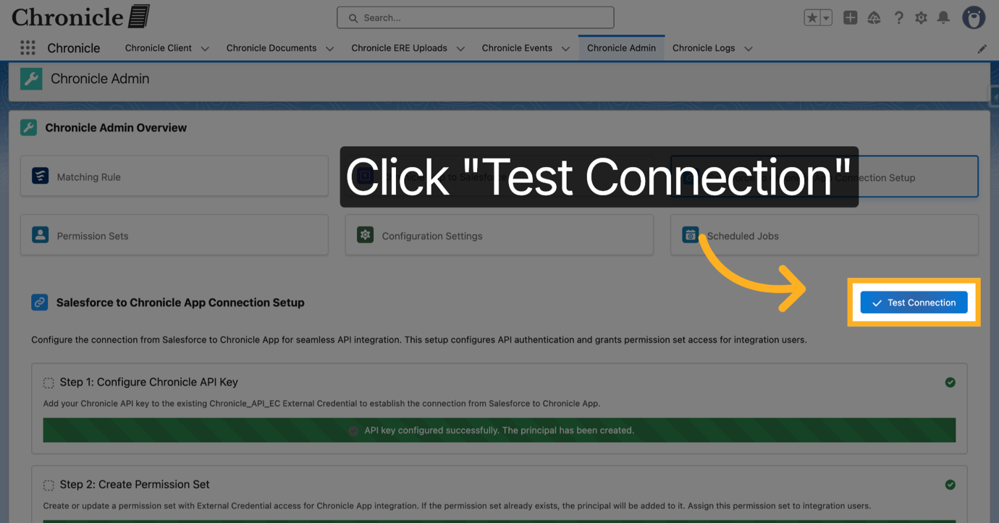
48. Confirm Successful Connection
Click Success to acknowledge that the connection test was successful.
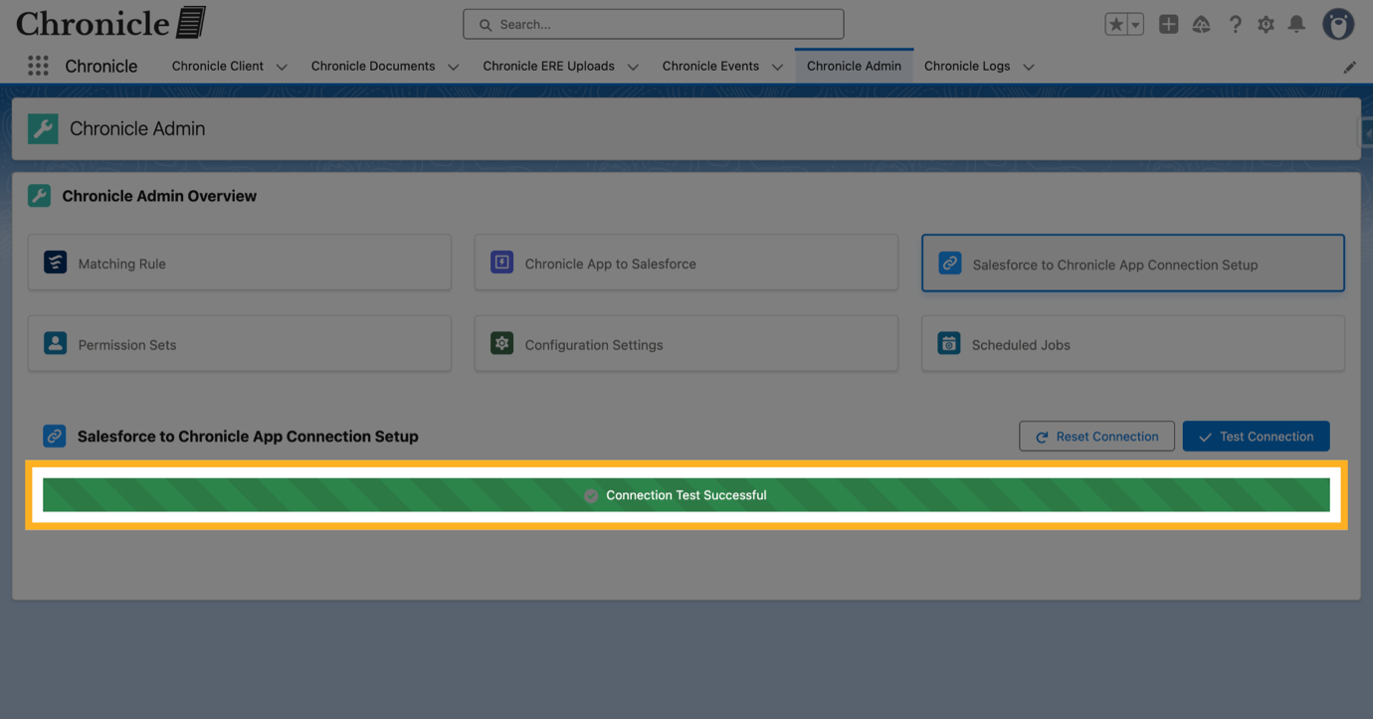
49. Open Permission Sets
Click Permission Sets to manage user access permissions.
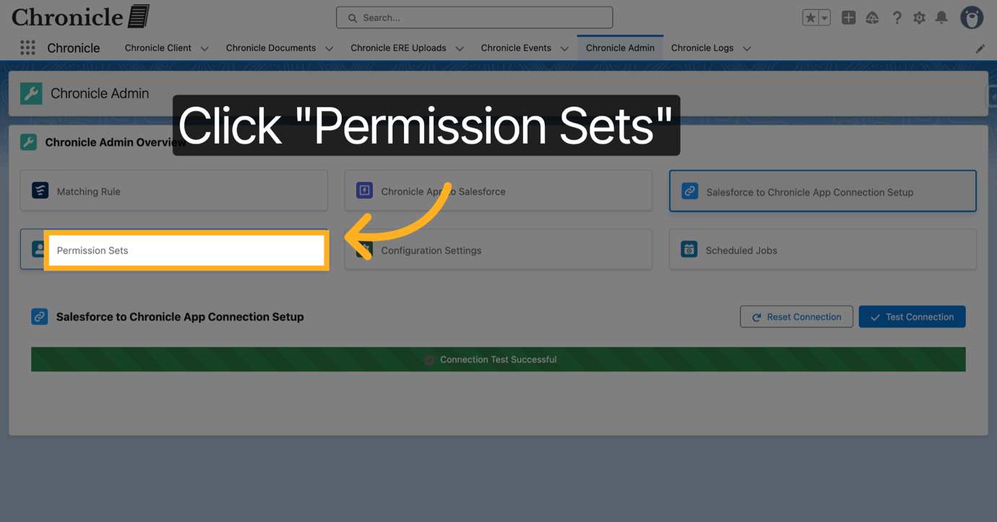
50. Open Add/Remove Users
From this view you can add or remove users from all of the Chronicle Permission Sets. Remember that the integration user needs the "Chronicle Integration User".
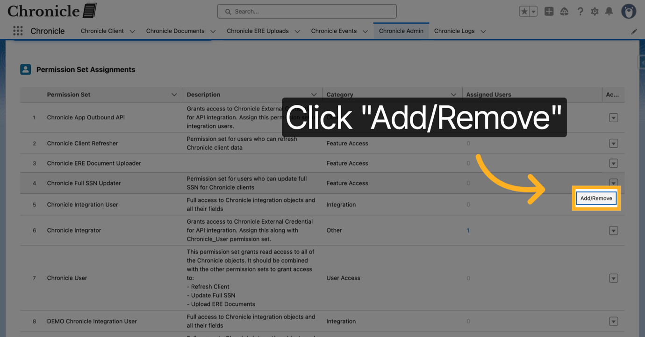
51. Select Integration User
Select the appropriate users.
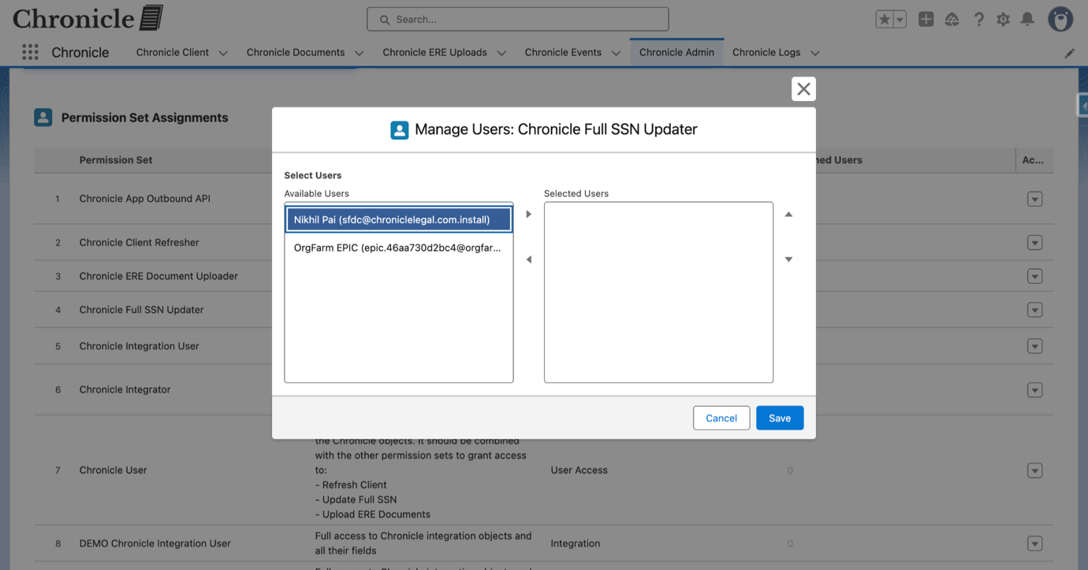
52. Save User Assignments
Click Save to confirm the user assignment changes.
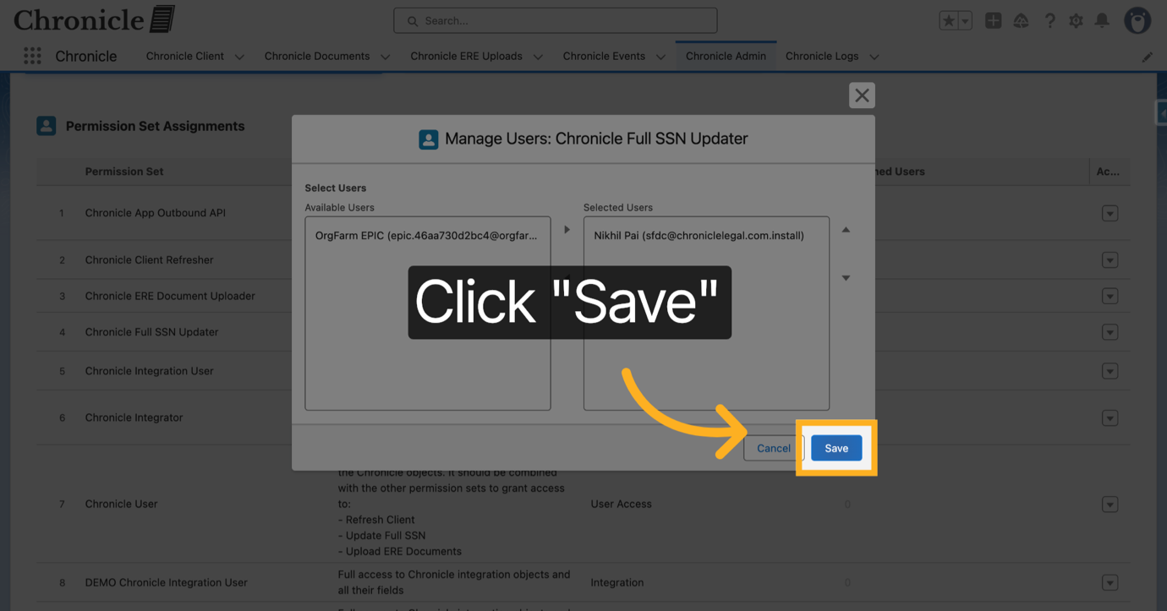
You have successfully completed the Chronicle App setup in Salesforce, including installation, matching rule creation, API integration, and permission set configuration. Verify the connection and user permissions to ensure seamless app functionality and integration.
Powered by guidde

